**Practical No. 1**

1. **Write a program for tokenization of given input.**

**Code:**

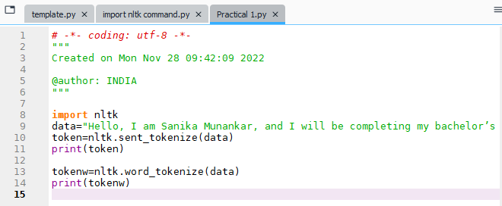

**Output:**

